Name: Huajie Chen

Matrikelnr: 4199962

1. **Visualization**

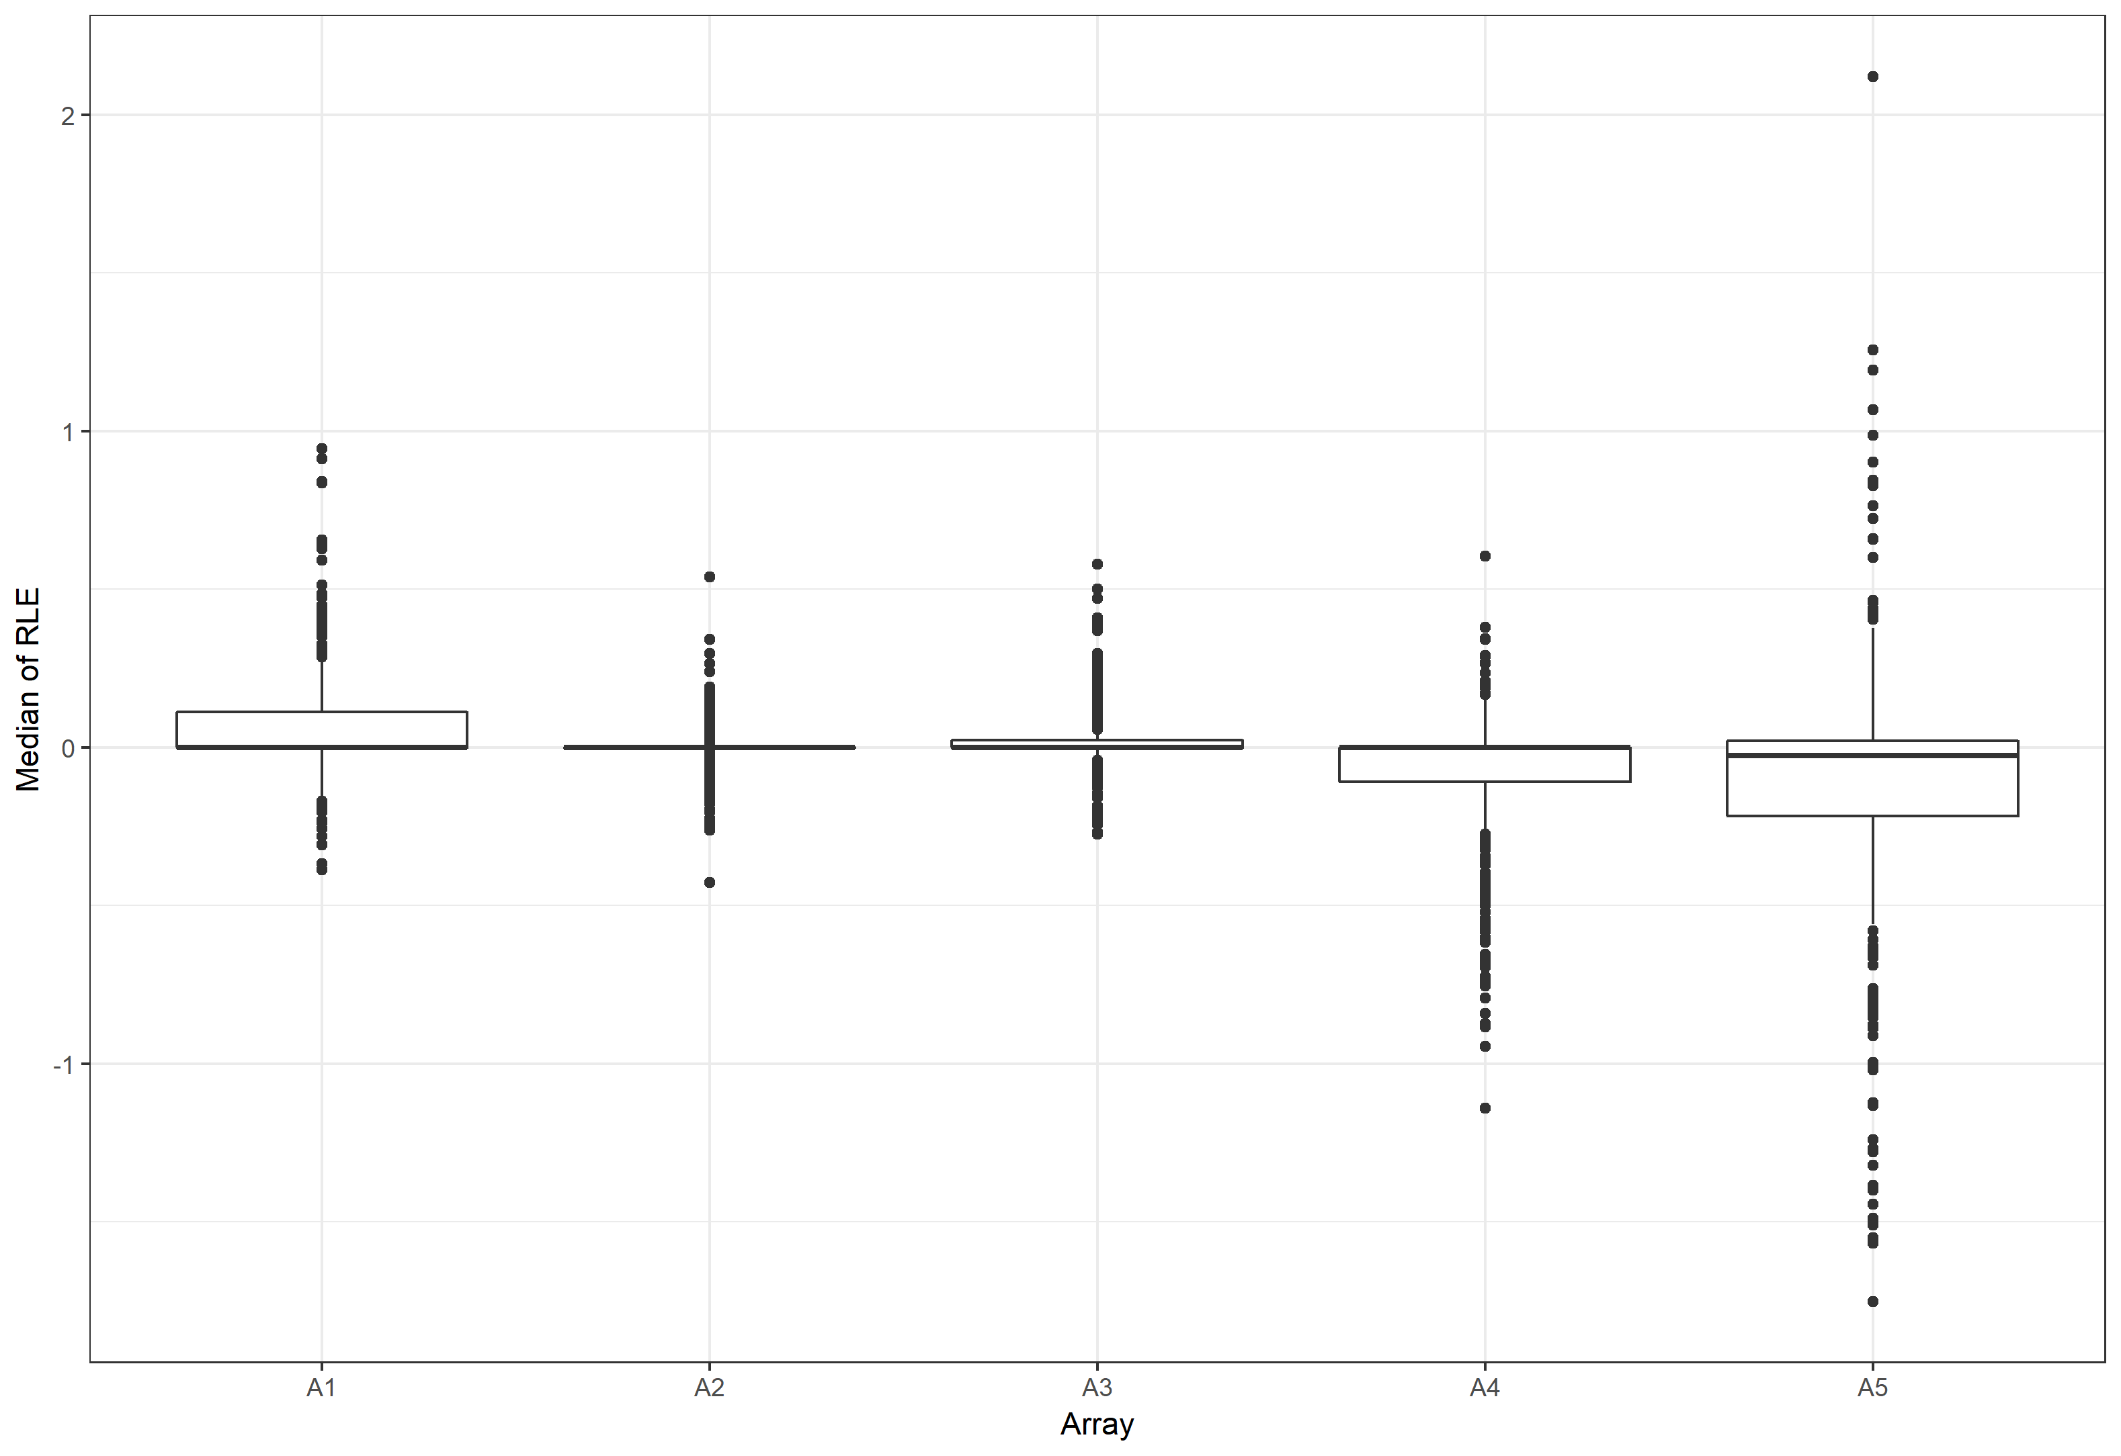

RLE Box-Plot

* Medians of relative logarithmized expression value from each probe on each array are chosen and plotted. It is designed to signify the difference of probe on every array in general.
* X-axis is for the arrays and Y-axis is for the median of RLE values. Besides, the medians and quantiles of each plot can also be observed from it.
* From this plot, the expression level in this specific condition on each array in general can be observed. Meanwhile, it also tells the difference between array and array.

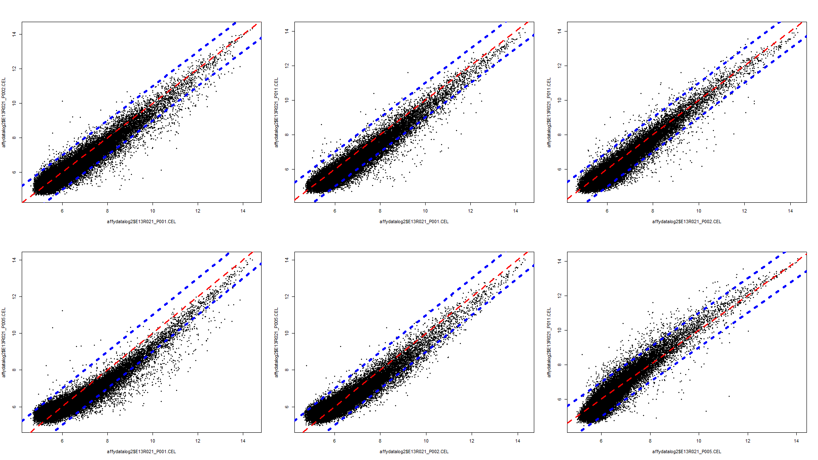

Pairwise Scatterplot(s)

* The primary expression values(PEV) of each pair of arrays are plotted. It is designed to make specific comparation for each pair of arrays.
* X-axis is for the PEV of array 1 and Y-axis is for the PEV of array 2. The points on the red line stand for the equilibrium of PEV on both arrays. As for the points on the blue lines, they stand for the 2-times-higher PEV than on the other array.
* From this plot, the PEV for the entire group of probes on both array can be observed in a comparation. Therefore, on which array it is generally with higher PEV can be seen.

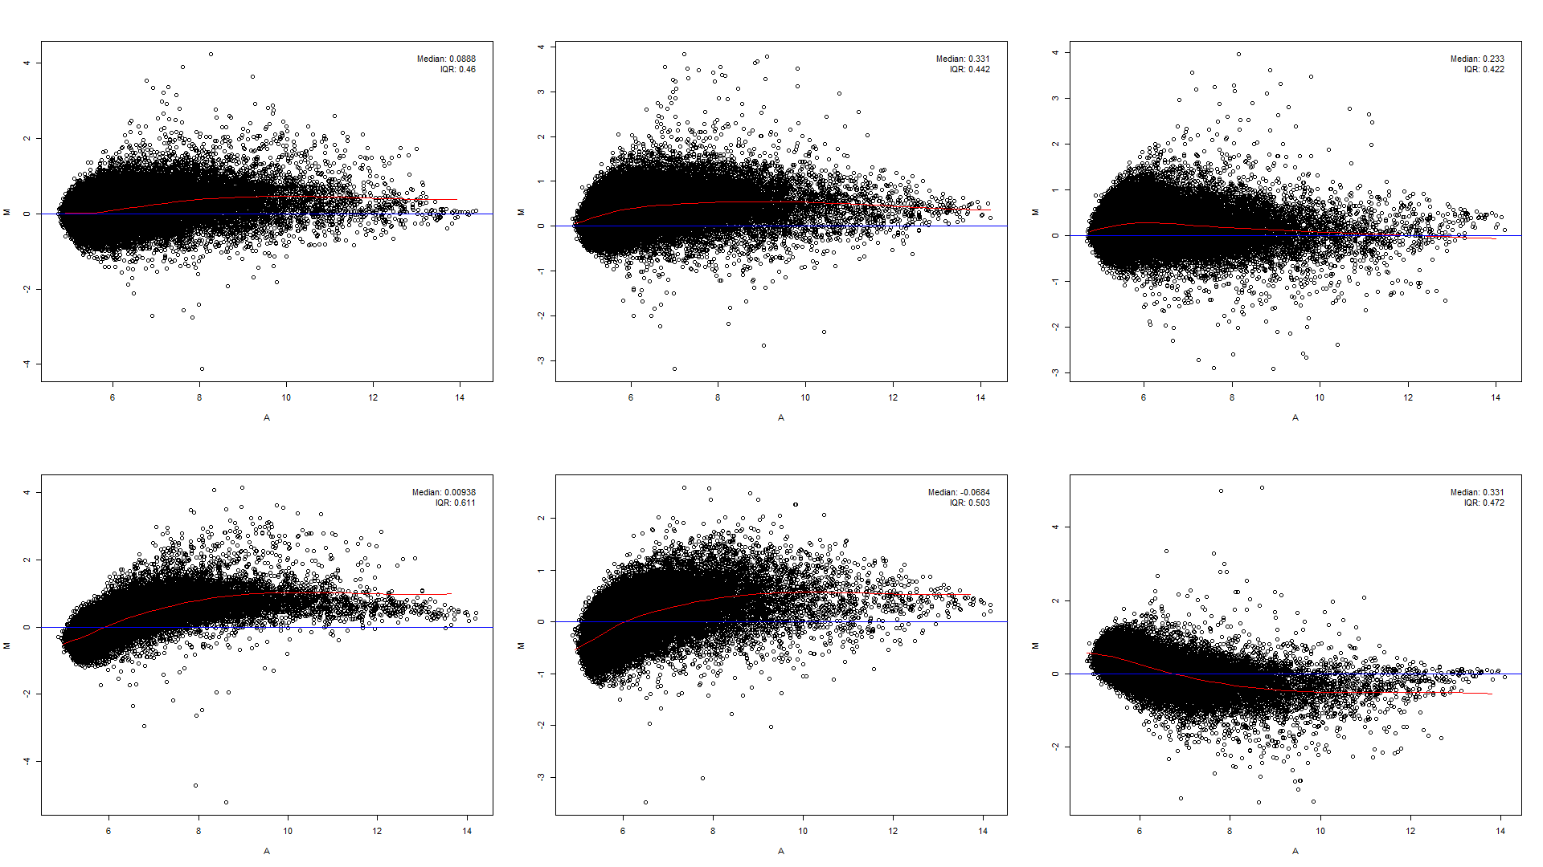

* From this plot, the M, A value for the entire group of probes on both array can be observed in a comparation. Therefore, on which array in every interval of specific average log intensity it is generally with higher relative expression value can be seen. And with the red line we can interpret the expression level in general easily.

MA Plot(s)

* The PEVs of each pair of arrays are processed with log2() firstly and thereafter generate the M and A value.
* X-axis is for A value and Y-axis is for M value. M is, therefore, the binary logarithm of the intensity ratio (or difference between log intensities) and A is the average log intensity for a dot in the plot. The red line is where the y-median of dx lies while the blue line stands for the equilibrium of PEV on both arrays. Legends are plotted on the upper right.

2. Drawing task: Experimental Design of Microarray Experiments

The given condition is that a colleague wants to measure and compare the transcriptomes of six biological replicates of a certain cell type with dual color microarray as efficient as possible.

Therefore, I suggest that the six biological replicated transcriptomes should be pooled first in order to make average from them as reference（R）. And then each transcriptome can be compared to R.

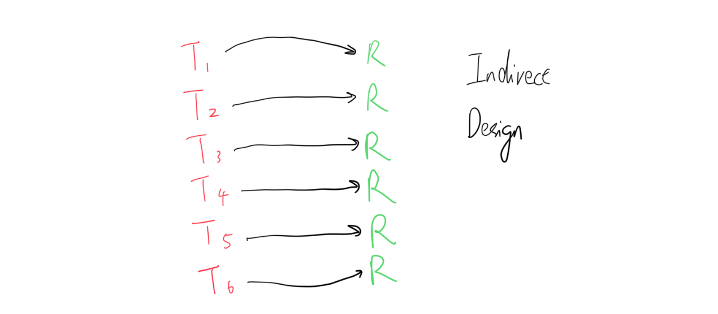

By this indirect design, 6 transcriptomes can be can be measured and compared with only 6 arrays, which, in my opinion, is the cheapest design and also effective.